Vibrational spectroscopy of synthetic analogues of ankoleite, chernikovite and intermediate solid solution

N. Clavier ^{1,*}, F. Crétaz ¹, S. Szenknect ¹, A. Mesbah ¹, C. Poinssot ²,
M. Descostes ³, N. Dacheux ¹

¹ ICSM, Institut de Chimie Séparative de Marcoule, UMR 5257 CEA/CNRS/ENSCM/Université de Montpellier, Site de Marcoule – Bât. 426, BP 17171, 30207 Bagnols/Cèze cedex, France
² CEA/DEN/DRCP/DIR, Site de Marcoule – Bât. 400, BP 17171, 30207 Bagnols/Cèze cedex, France
³ AREVA Mines / R&D Dpt, La Défense, 92084 Paris, France

* Corresponding author :
Dr. Nicolas CLAVIER
ICSM – UMR 5257 CEA/CNRS/ENSCM/Université de Montpellier
Site de Marcoule – Bât 426
BP 17171
30207 Bagnols sur Cèze
France

Phone : + 33 4 66 33 92 08
Fax : + 33 4 66 79 76 11

nicolas.clavier@icsm.fr

Abstract :

Ankoleite (K(UO₂)PO₄·nH₂O), chernikovite (H₃O(UO₂)PO₄·nH₂O) and intermediate solid solutions are frequently encountered in the uranium ores that result from the alteration of uranium primary minerals. This paper reports a thorough FTIR and Raman study related to synthetic analogues for these minerals. First, the vibration bands associated to the UO₂²⁺ uranyl ion were used to calculate the O=U=O bond length which appeared in good agreement with the data coming from XRD data. Then, the examination of the phosphate vibration modes in both sets of spectra confirmed the general formulation of the samples and ruled out the presence of hydrogenphosphate species. Finally, the presence of H₂O as well as protonated H₃O⁺ and/or H₅O₂⁺ species was also pointed out, and could be used to clearly differentiate the various phases prepared. Vibrational spectroscopy then appeared as an efficient method for the investigation of such analogues of natural samples. It should be particularly relevant when identifying these phases in mineral ores or assemblies.

Keywords :

Ankoleite – Chernikovite – Uranium – Phosphate – Synthetic analogues - Spectroscopy

1. Introduction

Uranium(VI) phosphates constitute an important part of the so-called secondary minerals, that result from the alteration of the primary pitchblende . Among them, the more generally encountered are probably autunite, Ca(UO₂)₂(PO₄)₂·nH₂O, as well as torbernite, Cu(UO₂)₂(PO₄)₂·nH₂O, that constitute parent compounds of a large family of minerals adopting comparable crystal structures. If both compounds are commonly described as 2D layered structure with sheets composed by UO₂²⁺ ions and phosphate polyhedrons, they mainly differ through the size and the coordination of the cation hosted in the interlayer space, and through the subsequent number of water molecules also located between the layers . Consequently, a wide variety of less abundant phosphate compounds containing sodium, iron, magnesium or barium frequently occur in uranium ores of economic interest . Several of these phases remain hardly identifiable, due to their poor occurrence, but also to structural and textural characteristics close to that of the parent compounds . In these conditions, the progresses made during the last years in portable Raman spectrometers could allow this technique to be used on the field in order to supply important help in the identification of rare minerals , that appears mandatory to characterize extensively the mining sites to be exploited.
In the same time, numerous compounds belonging to the general uranyl-based mineral group with the general formula M(UO₂)XO₄·nH₂O (where X = P or As and M is a monovalent cation), were extensively investigated in the framework of their application as cationic exchangers or as solid electrolytes for proton conductivity . Among this family, K(UO₂)PO₄·nH₂O and H₃O(UO₂)PO₄·nH₂O were particularly studied and appear to constitute synthetic analogues of the natural minerals ankoleite and chernikovite, respectively. Although numerous data were reported concerning the crystal structure of these compounds (tetragonal, space group P4/ncc) and their phase transitions occurring both at low or high temperatures , vibrational spectra remain poorly documented , especially concerning Raman spectroscopy.
In the present study, the preparation then the characterization of synthetic analogues of ankoleite and chernikovite, as well as that of intermediate solid solution, was then undertaken through vibrational spectroscopy, namely Raman and FTIR. Particularly, the relevant aspects dealing with the spectral features of uranyl molecular ion, phosphate polyhedrons, and H₂O-derived species will be discussed in link with the crystal structure of the samples.
2. Experimental

2.1 Preparation and characterization of the samples

All the chemicals used during the preparation of the powdered samples, except U(VI) solution, were supplied by Sigma-Aldrich and were of analytical grade. Uranyl nitrate solution was obtained by the dissolution of the corresponding salt in 0.05 M HNO₃ in order to reach uranium concentrations ranging between 0.5-1.5 M.
H₃O(UO₂)PO₄·nH₂O, also frequently called HUP, was prepared as a synthetic analogue of the natural chernikovite through the protocole reported by Vochten and Deliens . Concentrated phosphoric acid (2 M) and uranyl nitrate were mixed in an open vessel, considering a ratio P/U = 1.1 in order to ensure the quantitative precipitation of the cations. The mixture of solutions was further stirred during 1 hour at room temperature then aged during 3 days. The precipitate formed was separated from the supernatant by centrifugation (4500 rpm, 3 minutes), washed several times with deionized water and ethanol and finally dried at 40°C in an oven.
Similar procedure based on wet chemistry method was applied for the preparation of K(UO₂)PO₄·nH₂O (KUP), standing as synthetic analogue for ankoleite. Uranyl nitrate, potassium nitrate and phosphoric acid were thus mixed in stoichiometric proportions in a sealed PTFE reactor, then placed in an oven at 60°C for four days. Nevertheless, the yellow crystals obtained thereafter were always composed by a mixture of ankoleite and chernikovite. Such incomplete reaction was already observed during attempts to perform the direct synthesis of autunite by Vochten et al. . Pure ankoleite was then further obtained through cationic exchange reaction, by immerging the powdered sample in concentrated KNO₃ solution (1 M, pH = 2) for 7 days, considering a molar ratio of U/K = 1/2. Moreover, intermediate (K,H₃O)(UO₂)PO₄·nH₂O solid solution (thereafter noted as (K,H)UP) was obtained through the reverse cationic exchange, i.e. by placing ankoleite in 1M HNO₃ for about 1 month. In these conditions, potassium was partly substituted by hydronium ions.
For each synthesis, the resultant powder was analysed by powder X-ray diffraction (PXRD) using the Bruker D8 advance diffractometer equipped a lynxeye detector and having copper radiation (λ K_{α1,2}=1.54184Å). The collected PXRD patterns (Figure 1a) showed the formation of single and pure phases of HUP, (K,H)UP, and KUP, all adopting the same structural type. Indeed, chernikovite and ankoleite compounds are isostructural and both crystallize in the P4/ncc space group of the tetragonal system .
Each uranyl group is coordinated equatorially to four oxygen atoms to form distorted octahedrons. Each of those is connected to the phosphate groups through the share of oxygen corners to form 2D layers perpendicular to the c axis. These layers are separated by water molecules and randomly disordered H₃O⁺ (HUP) and/or K⁺ (KUP) . A general view of the structure is presented down the a axis in Figure 1b, drawn from the crystal data reported by Fitch and Cole .

(a) |  | (b) | 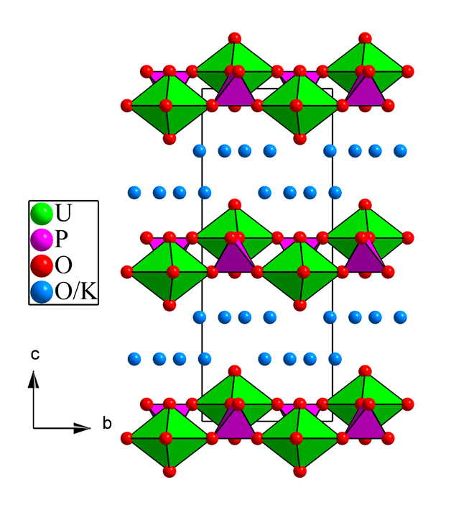

Figure 1. (a) PXRD patterns recorded for synthetic analogues for ankoleite (KUP), chernikovite (HUP), intermediate solid solution (K,H)UP and comparison with ISCD file #71328 (K(UO₂)PO₄)·3D₂O) . (b) General view of the chernikovite/ankoleite structure down the a axis, drawn from the crystal data reported by Fitch and Cole .

SEM micrographs were then recorded by the means of a FEI Quanta 200 electronic microscope (Figure 2) to evidence the morphology of the samples prepared. Ankoleite was found to crystallize as large platelet-type crystals up to 50 µm in length. Such morphology is in good agreement with its 2D-layered structure, and was also reported for other uranyl phosphates belonging to the same family, such as autunite or meta-torbernite . Intermediate (K,H)UP sample exhibited a comparable morphology. However, due to its preparation route, the edges of the particles appeared to be more rounded, probably as a result of the alteration of the initial ankoleite in 1M HNO₃. Chernikovite formed smaller square-shaped platelets with a size close to 5 µm. Such morphology is probably inherited from the conditions of synthesis since they provide very rapid precipitation of the sample, generally associated with a small size of crystal.

KUP | (K,H)UP | HUP
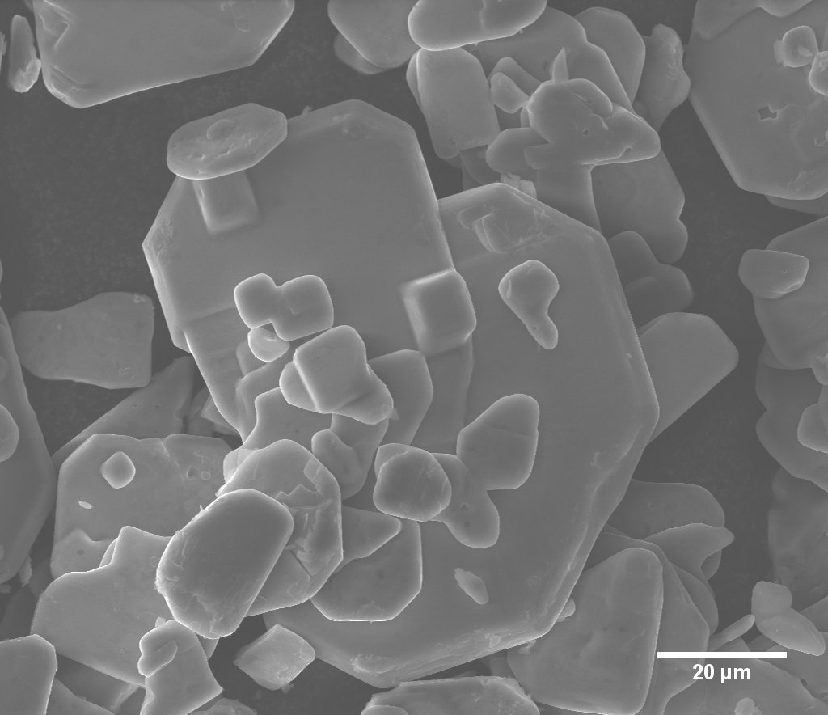 | 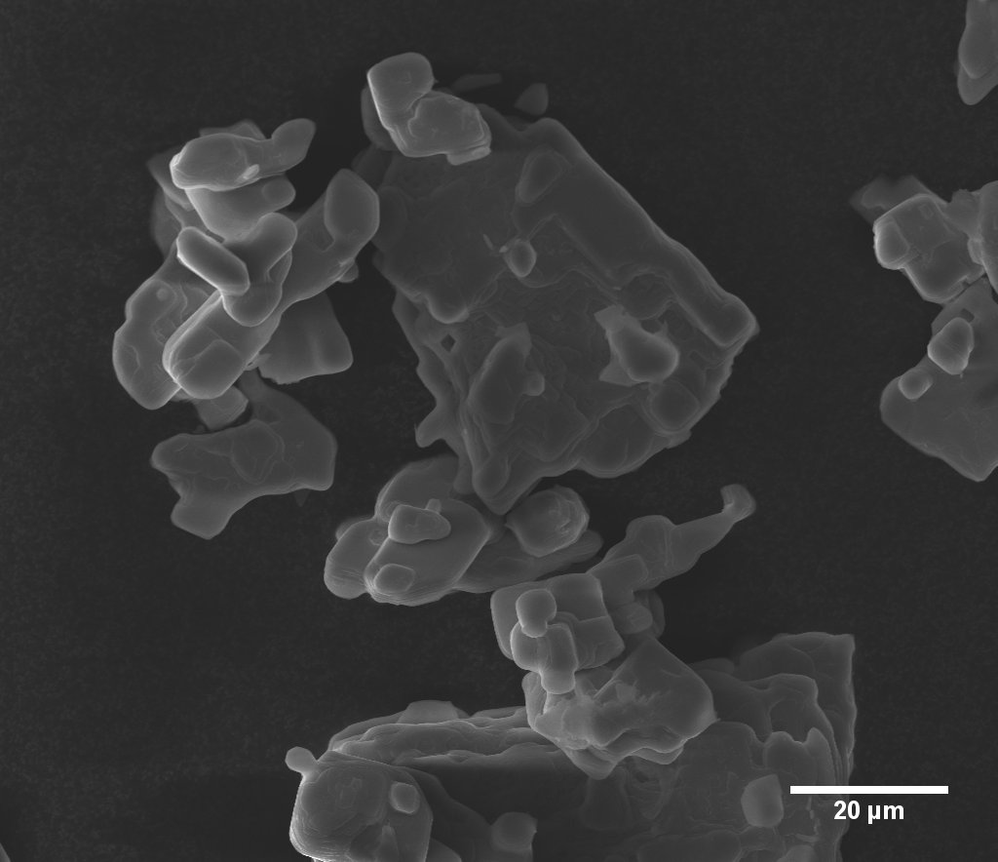 | 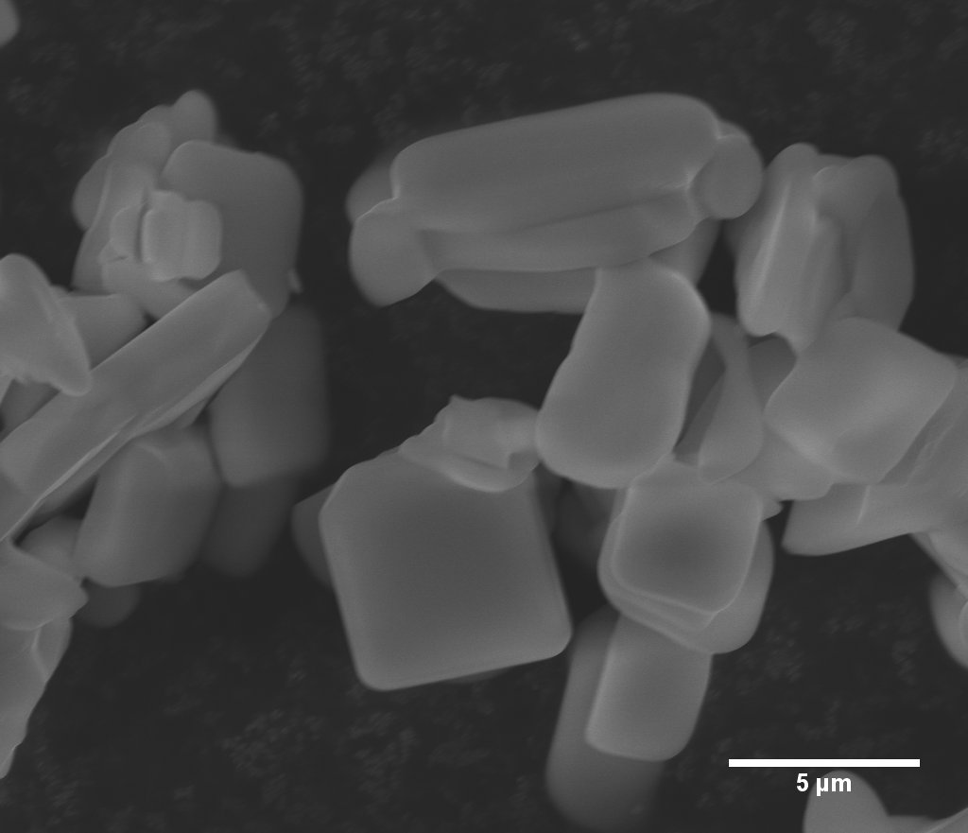

Figure 2. SEM observations of synthetic analogues for ankoleite (KUP), chernikovite (HUP) and intermediate solid solution (K,H)UP.

Finally, in order to check the stoichiometry of the solids prepared, the complete dissolution of 2-6 mg of powder was undertaken in 4M HNO₃. The concentration of the various elements of interest in the resulting leachate was further determined by the means of ICP-AES (Spectro Arcos EOP). Prior to the analyses, the apparatus was calibrated with SPEX standard solutions diluted to concentrations ranging from 0.1 to 15 mg.L⁻¹. The results reported in Table 1 confirmed that the U/P ratio was found systematically close to 1, in good agreement with the general formulae of the minerals belonging to the torbernite family. Chemical analysis also allowed the determination of the precise composition of the intermediate solid solution which was characterized by a K/U mole ratio of about 0.4. Moreover, it is to note that for the KUP sample, a small depletion in potassium was evidenced, probably coming from an incomplete cationic exchange in the experimental conditions described above. Nevertheless, the potassium content appears largely higher than in the (K,H)UP sample, and KUP still can be considered as a convenient analogue of ankoleite.
The water content of the various compounds prepared was also evaluated through TG analyses performed on a Mettler-Toledo STAR^{e} system apparatus. Powdered samples were heated up to 1000°C (5°C.min⁻¹) under air atmosphere. The relative weight loss observed between room temperature and 500°C (see supplementary material, Figure S1) was assigned to the full dehydration of M(UO₂)PO₄·nH₂O, and led to n values ranging from 2.5 to 4.5 (Table 1). The water content then appeared to increase when going from ankoleite to chernikovite analogues, in good agreement with the formulae reported in the literature for these two compounds .

Table 1. Determination of the chemical composition of the samples through complete dissolution and ICP-AES measurements, and TG analyses.
 | U (mol.L⁻¹) | P (mol.L⁻¹) | K (mol.L⁻¹) | U/P | K/U | nH₂O | Experimental formula
KUP | (1.5±0.2)×10⁻³ | (1.4±0.2)×10⁻³ | (1.3±0.2)×10⁻³ | 1.1±0.2 | 0.9±0.1 | 2.5 | K_{0.9}(H₃O)_{0.1}(UO₂)PO₄·2.5H₂O
(K,H)UP | (1.9±0.2)×10⁻³ | (2.1±0.2)×10⁻³ | (7.9±0.8)×10⁻⁴ | 0.9±0.1 | 0.4±0.1 | 3 | K_{0.4}(H₃O)_{0.6}(UO₂)PO₄·3H₂O
HUP | (3.8±0.4)×10⁻³ | (3.2±0.3)×10⁻³ | --- | 1.2±0.2 | --- | 4.5 | (H₃O)(UO₂)PO₄·4.5H₂O

2.2. Raman spectroscopy

Raman spectra were recorded by the means of a Horiba - Jobin Yvon Aramis apparatus equipped with an edge filter and using a Nd:YAG laser (532 nm). In order to avoid any laser-induced degradation of the samples, the power was turned down by the means of optical filters to about 1-4 mW at the sample surface, depending on the chemical composition of the compound analyzed. The laser beam was then focused on a small fraction of powdered sample simply deposited on a glass lamella using an Olympus BX 41 microscope. A ×100 objective with a numerical aperture of 0.9 was used, resulting in a spot size of about 1 μm². The scattered Raman light was collected in a 180° backscattering geometry and dispersed by a grating of 1800 grooves/mm after having passed a 150 µm entrance slit, resulting in a spectral resolution lower than 1 cm⁻¹. For each spectrum, a dwell time of 90 to 180 seconds was considered with an average of 3 scans. Before analysis, the apparatus was calibrated with a silicon wafer, using the first-order Si line at 520.7 cm⁻¹.

2.3. FTIR spectroscopy

FTIR spectra were recorded in the 380-4000 cm⁻¹ range thanks to a Perkin-Elmer FTIR Spectrum 100 device. Powdered samples were deposited at the surface of an ATR crystal without any prior preparation. The spectra collected in such operating conditions exhibited a resolution lower than 2 cm⁻¹.
3. Results and discussion

3.1 General overview

The FTIR and Raman spectra recorded for the synthetic analogues of ankoleite (hereafter noted KUP), chernikovite (HUP) and associated (K,H)UP solid solutions are gathered in Figure 3. Band component analysis of the different data sets was carried out by the means of the Jandel Peakfit software, using pseudo-Voigt functions (Gaussian-Lorenzian ratio systematically higher than 0.7) with the minimum number of components. Correlations coefficients r² greater than 0.992 were usually obtained for the results reported in Table 2.
Figure 3. FTIR and Raman spectra recorded for the synthetic analogous to ankoleite (KUP), chernikovite (HUP) and associated solid solutions (K,H)UP.

Table 2. Assignment of the vibration bands observed on the FTIR and Raman spectra recorded for synthetic analogues of ankoleite (KUP), chernikovite (HUP) and intermediate solid solution (K,H)UP.
FTIR |  |  |  | Raman
KUP | (K,H)UP | HUP | Band assignment | KUP | (K,H)UP | HUP | Band assignment
 | 417 |  | ν₂(PO₄) | 108 | 105 | 110 | Γext.
 | 423 |  |  | 113 | 115 | 193
 |  |  |  | 173 | 194 | 287
529 | 518 | 530 | ν₄(PO₄) | 195 | 211
541 | 540 | 543 |  | 291 | 247
 |  |  |  |  | 286
 | 621 | 613 | Γext.
 |  |  |  | 400 | 402 | 402 | ν₂(PO₄)
666 | 692 | 694 | R’(H₂O)
 |  |  |  |  |  | 458 | ν₄(PO₄)
813 | 815 | 823 | ν₁(UO₂)
 |  |  |  | 826 | 840 | 842 | ν₁(UO₂)
866 | 869 | 879 | ν₃(UO₂) | 831
904 | 905 | 911
 |  |  |  | 994 | 1000 | 986 | ν₁(PO₄)
985 | 979 | 969 | ν₁(PO₄) | 1004 |  | 999
1059 | 1030 | 1021
1109 | 1057 | 1094 | ν₃(PO₄) |  | 1051 |  | ν₃(PO₄)
 | 1243 | 1427 | δ(H₂O₅⁺) | 2786 | 2869 | 3078 | ν(H₂O)
 |  | 1466 |  | 3110 | 3227 | 3215
 |  |  |  | 3237 | 3454 | 3425
1622 |  | 1638 | δ(H₂O) | 3375
1658 |  |  |  | 3498
 |  |  |  | 3805
 | 1736 | 1718 | δ(H₃O⁺)
 | 1843 | 1791
2990 | 2621 | 2867 | ν(H₃O⁺)
 | 2990
3201 | 3248 | 3044 | ν(H₂O)
3350 | 3448 | 3211
3468 | 3589 | 3394
3589

As expected from their common crystal structure, all the three compounds investigated present very similar vibrational spectra, which can be analyzed by considering three different zones. The 600-1100 cm⁻¹ range corresponds to the region where the stretching vibrations modes (both symmetric and antisymmetric) can be observed for PO₄³⁻ tetrahedrons and UO₂²⁺ molecular ions. Correlatively, the region between 100 and 600 cm⁻¹ was dedicated to the study of the bending modes of the phosphate entities. External vibration modes (lattice modes) were also assigned to this range of wavenumbers. Finally, the 2000-4000 cm⁻¹ range was investigated to characterize the vibration modes correlated to the water molecules and associated protonated entities located in the interlayer space of the chernikovite-type structure. Although hardly visible on the Raman spectra, these features remain essential to analyze as they are expected to be significantly modified when shifting from ankoleite to chernikovite. The results corresponding to these three different regions, therefore to uranyl, phosphate, and water-related species vibrations, will be discussed in the following sections.

3.2 Uranyl molecular ion

Uranyl molecular ion, namely UO₂²⁺, was widely studied by the means of vibrational spectroscopy in a large variety of materials, including minerals, owing to its strong signal observed both by Raman and FTIR. Three modes of vibration are usually reported in the literature, and were assigned to symmetric (ν₁) and anti-symmetric (ν₃) stretching of the O=U=O pattern, as well as to its bending (ν₂). Since only the ν₁ mode is expected to be Raman-active, it corresponds to the most intense vibration band observed on the spectra, and is located between 825 and 845 cm⁻¹ depending on the composition of the solid considered (Figure 4). The variation of the ν₁ wavenumber could then be linked to the modification of the cation located in the interlayer space, which is expected to slightly impact the U=O bond length. In these conditions, the progressive substitution of K⁺ by H₃O⁺ when going from ankoleite to chernikovite analogue was accompanied by a shift of ν₁ towards the upper wavenumbers. Such modification was already stated in the past through the study of the ν₃ vibration mode observed by FTIR . Nevertheless, it is to note that from our data, the position of the ν₁ vibration band observed for the intermediate (K,H)UP sample (840 cm⁻¹) was found very close to that of HUP (842 cm⁻¹). On this basis, and owing to the chemical composition determined from ICP-AES measurements, one can suppose that the variation of the ν₁ wavenumber versus the K⁺ content is not linear, and that the behaviour of proton-enriched solid solutions is very similar to that of chernikovite.
Moreover, the empirical law reported by Bartlett and Cooney led us to quantify the U=O bond length variation then to allow its comparison with the data reported in the literature from XRD data or theoretical calculations. Although these formulas were established from the study of silicate compounds (including zeolithes), many authors proved that they could be applied to phosphate-based phases . Hence, the R_{U=O} distance can be expressed as :

R_{U=O} = 10650 × [ν₁(UO₂²⁺)]^{-2/3} + 57.5 (1.)
or
R_{U=O} = 9141 × [ν₃(UO₂²⁺)]^{-2/3} + 80.4 (2.)

where R_{U=O} is expressed in pm; and [₁(UO₂²⁺)] and [₃(UO₂²⁺)] are the vibration band wavenumbers (in cm⁻¹) corresponding to the uranyl ion in the Raman and FTIR spectra, respectively.
Figure 4. FTIR spectra in the 570-1150 cm⁻¹ region and Raman spectra in the 750-1100 cm⁻¹ range.

The values obtained from spectroscopic data (Table 3) generally appeared in fair agreement with that reported in the literature, even if the bond lengths determined from FTIR were systematically found higher than that coming from Raman. Also, for all the compounds studied, two bands were systematically assigned to the ν₃ vibration mode of UO₂²⁺ in FTIR, even if the band component analysis was in this case complicated by the overlap with PO₄ stretching modes. Such unexpected splitting could be linked to the structural studies dedicated to KUP and HUP that generally argue for a dissymmetric uranyl motif with two slightly different U=O bonds. As a matter of fact, the U=O distances determined in the case of the synthetic analogue for ankoleite in this work fits very well with that determined from neutron powder diffraction refinement by Fitch and Cole . Satisfactory agreement was also attained for the chernikovite analogue, either when considering structural data coming from PXRD measurements or ab initio calculations . These results thus confirms that the empirical formula proposed by Bartlett and Cooney can be used as a convenient tool for the evaluation of uranyl molecular ion geometry within phosphate-based minerals, as already mentioned in the literature. Moreover, it was found to be more accurate than the relation employed by Pham-Thi et al. , who proposed a U=O bond length close to 1.755 Å for K(UO₂)PO₄·nH₂O on the basis of their FTIR data.

Table 3. Determination of the U=O bond length from FTIR and Raman data and comparison to data reported in the literature.
 | R_{U=O} (Å)
 | Raman | Infrared | Reference
KUP | 1.78 ± 0.04  1.79 ± 0.04 | 1.80 ± 0.04  1.78 ± 0.04 | 1.797 ± 0.005  1.777 ± 0.005
(K,H)UP | 1.77 ± 0.04 | 1.81 ± 0.04  1.78 ± 0.04 | ---
HUP | 1.77 ± 0.04 | 1.80 ± 0.04  1.78 ± 0.04 | 1.801  1.787
HUP | 1.77 ± 0.04 | 1.80 ± 0.04  1.78 ± 0.04 | 1.78 ± 0.01  1.75 ± 0.01

3.3 Phosphate groups

The bands resulting from the vibration modes of the P-O bonds within the PO₄ tetrahedrons are generally split into two distinct sets corresponding to bending and stretching modes. In this study, bending vibrations were observed close to 400 cm⁻¹ on the Raman spectra, and in the 400-650 cm⁻¹ range for FTIR (Figure 5). While a single vibration band was observed in Raman and assigned to the symmetric bending of PO₄³⁻ (ν₂), the deconvolution of the signal observed at 540 cm⁻¹ in FTIR, corresponding to the ν₄ antisymmetric mode, always led to two components. For the (K,H)UP solid solution, the gap between these two bands was even amplified and suggested that it resulted from the random presence of K⁺ or H₃O⁺ cations in the local environment of the phosphate tetrahedrons. In this particular case, it was also associated with the activation of the ν₂ mode (doublet at 417 and 432 cm⁻¹) which is usually inactive in infrared. On this basis, the alternation of K⁺ and H₃O⁺ cations in the interlayer space of the chernikovite-type structure probably results in local symmetry breaks that modify the geometry of some PO₄³⁻ polyhedrons. Also, the presence of water molecules in the interlayer space could contribute to decrease their local symmetry. Indeed, similar spectra were obtained for other hydrated uranyl phosphate minerals (such as uranocircite or meta-torbernite), in which the site symmetry of the phosphate was lowered from T_{d} to S₄ .
On the other hand, the antisymmetric and symmetric stretching modes appeared at higher wavenumbers, generally between 900 and 1100 cm⁻¹ (Figure 4) . In this area, it is once again to note that the band component analysis of the FTIR spectra was complicated because of the overlap of the PO₄³⁻ and UO₂²⁺ stretching modes. The ₁(PO₄) mode is systematically characterized by a main vibration band (located at 994, 1000 and 999 cm⁻¹, respectively for KUP, (K,H)UP and HUP), associated to a second band of weak intensity. As stated previously, these latter probably result from differences in the direct environment of the phosphate groups (H₃O⁺ or K⁺ cations) or from local symmetry breaks that can be linked with the presence of hydration water in the interlayer space. The presence of the bands with small intensity in the 900-1100 cm⁻¹ region thus probably does not account for a global modification in the geometry of the PO₄ entities. Similar conclusions can also be drawn from the study of FTIR spectra since the ₁(PO₄) was again systematically found to appear with two components, one of them generally being of low intensity. Whatever the spectroscopy technique considered, the ₂ and ₃ symmetric PO₄ vibration modes can thus be considered as fully degenerated (negligible influence of factor group splitting) and reflect the existence of undistorded PO₄ tetrahedrons in a highly symmetric structure , in good agreement with the tetragonal lattice reported from PXRD studies.

Figure 5. FTIR spectra in the 400-570 cm⁻¹ region and Raman spectra in the 100-500 cm⁻¹ range.

Moreover, apart from the uranyl ion stretching mode discussed above, no vibration mode was found in the 700-900 cm⁻¹ range in our spectra, which rules out the existence of condensed phosphate species in the various samples studied, such as P₂O₇⁴⁻ entities. More importantly, no vibration band characteristic of hydrogenphosphate groups, generally reported around 910 cm⁻¹ (Raman) and 1250 cm⁻¹ (FTIR) , was evidenced. This confirms that the fully-protonated sample prepared in this study truly corresponds to the chernikovite type and does not include any P-OH bond . Also, the absence of vibration bands associated to the HPO₄²⁻ groups for the (K,H)UP intermediate compound attests that no uranyl hydrogenphosphate hydrate (UO₂)(HPO₄)·3H₂O was formed during the alteration of the ankoleite analogue leading to the formation of the solid solution.

3.4 Water molecules and associated entities

Along with the water molecules located in the interlayer space of the chernikovite-type structure of both ankoleite and chernikovite, H₃O⁺ cations, that are present in variable amount in all the three samples studied, are expected to generate vibration bands associated to the bending and stretching of O-H bonds. Additionally, the existence of combined H₅O₂⁺ entities was also reported previously in HUP, and correlated with the apparition of specific vibration bands on both FTIR and Raman spectra . All these features are usually reported between 1600 and 1750 cm⁻¹ for the bending modes, and from 2900 to 3600 cm⁻¹ for the stretching ones. Band component analysis results obtained from the FTIR and Raman spectra recorded in these regions for the samples studied is thus reported in Figure 6.
As frequently reported, the spectral profile observed by Raman in the 2000-4000 cm⁻¹ range is very broad and of low intensity, which precludes a precise band analysis. In a general way, the wide band observed could be decomposed into at least three different contributions, which all account for the O-H stretching vibrations of the water molecules. Such complex signal therefore indicates that the water molecules involved in the structure present different hydrogen bond strength . First of all, this is directly linked to the existence of an hydrogen bond network that stabilizes the 2D structure of the samples , which is particularly evidenced through the stretching modes observed in the 2700-3000 cm⁻¹ on the Raman spectra . For KUP and (K,H)UP samples, the complex structure of the signal could also be associated with the random distribution of K⁺, H₃O⁺ and H₂O over the water molecule sites, which induces a very disordered organization of the interlayer space .
Conversely to Raman spectra, FTIR provides more accurate information concerning the vibration modes of the O-H bonds and the nature of the species located in the interlayer space of the various samples prepared. The first characteristic feature observed was a broad vibration band located around 660-700 cm⁻¹ (Figure 4). It was assigned to the rotational libration mode of H₂O, the wavenumber observed in this study being in good agreement with those reported in the literature .
The vibration modes observed in the 1200-1800 cm⁻¹ area could then be assigned to three different species. For the protonated samples, i.e. (K,H)UP and HUP, sharp bands were observed at 1243, and around 1450 cm⁻¹, respectively. They were correlated to the deformation modes of the terminal H-O-H and H-O-O groups in H₅O₂⁺ . Indeed, such species, which can be seen as a monohydrated hydronium ion rather than a discrete ion, has been reported for long to present a distinct spectroscopic behaviour . Also, it is to note that such characteristic vibration modes were not observed in the analogue of ankoleite (KUP). On this basis, and even if a small amount of protonated H₂O species were suspected from the chemical analysis of the sample, it is likely that the presence of large amount of K⁺ precludes the formation of complex groups such as H₅O₂⁺.

Figure 6. FTIR spectra in the 1150-4000 cm⁻¹ region and Raman spectra in the 2000-4000 cm⁻¹ range.

The bending vibrations of the O-H bonds within H₂O were then observed close to 1650 cm⁻¹ in KUP and HUP samples. Nevertheless, for this latter as well as for the (K,H)UP solid solutions, the most intense vibration bands in this region were found between 1700 and 1800 cm⁻¹ and correlated to the OH bending in the hydronium ion. Once again, the absence of such signal in KUP could be correlated to the small amount of H₃O⁺ groups in the interlayer space.
Similar conclusions can also be drawn from the stretching vibrations of O-H bonds. On the one hand, the bands associated to H₃O⁺ were detected below 3000 cm⁻¹, mainly for (K,H)UP and HUP sample, along with the stretching modes belonging to water molecules involved in the hydrogen bond network . Indeed, the massif recorded for the synthetic analogue of ankoleite appeared to be less broad, and mainly composed by vibration bands located between 3200 and 3600 cm⁻¹. Such features were unambiguously assigned to the ν(H₂O) vibration modes. Hence, even if the signal associated to the water molecules and related species is frequently broad and ill-defined, it still can be used to point out the presence of protonated groups within the interlayer of the autunite-type structure.

4. Conclusion

Raman and FTIR spectra of synthetic analogues of ankoleite and chernikovite minerals, as well as intermediate solid solution were recorded and compared for the first time. The vibration bands observed were divided in three sets, depending on their assignment to either UO₂²⁺, PO₄³⁻ or H₂O groups. First, the vibration modes of the uranyl ion were used to determine the U=O bond length that is characteristic of the composition of the various samples prepared, in good agreement with the values reported from PXRD data. It can thus be used to discriminate these phases which present very close structures. The signal correlated to the bending and stretching vibrations of the P-O bonds within the PO₄ tetrahedrons were then found to be weakly modified by the K⁺/H₃O⁺ substitution, as the associated wavenumber shift was limited to less than 10 cm⁻¹. However, the simultaneous presence of large amounts of distinct cations randomly distributed in the interlayer space of the chernikovite-type structure led to a splitting of the fully degenerated vibration modes, which can be used to trace substitutions when they occur on a large composition range. Finally, the presence of protonated H₂O-based species, such as H₃O⁺ or H₅O₂⁺, was also pointed out by the FTIR study, and could allow one to clearly differentiate ankoleite from chernikovite or intermediate compound.
Vibrational spectroscopy then appeared as an efficient method for the investigation of natural samples. It should be particularly relevant when dealing with mineral ores, for which all the phases studied in this work are frequently merged together, and then hardly differentiable by the means of PXRD or optical measurements. Further work should then be undertaken to validate this method, based on FTIR and Raman measurements of various natural assemblies.

Acknowledgements

Authors would like to thank Bruno Corso (ICSM/L2ME) for performing SEM observations and Paul-Henri Imbert (ICSM/LIME) for the preparation of the (K,H)UP sample. They are also grateful to the Ressources project included in the NEEDS program (Nucléaire, Energie, Environnement, Déchets, Société) of CNRS for its continuous financial support.

Supplementary Material

Figure S1. TG analyses performed on synthetic analogues for ankoleite (KUP), chernikovite (HUP) and intermediate solid solution (K,H)UP.

References

[1] M. Cuney, K. Kyser, Recent and not-so-recent developments in uranium deposits and implications for exploration, Mineralogical Association of Canada, Quebec, 2008.
[2] A.J. Locock, P.C. Burns, T.M. Flynn, Can Mineral, 42 (2004) 1699-1718.
[3] A.J. Locock, P.C. Burns, Am Mineral, 88 (2003) 240-244.
[4] A.J. Locock, P.C. Burns, Can Mineral, 41 (2003) 489-502.
[5] I.G. Zhiltsova, L.I. Polypanov, E.M. Shmariovich, S.A. Perlina, Lithol Miner Resour, 20 (1986) 586-596.
[6] J. Jehlicka, P. Vitek, H.G.M. Edwards, M.D. Hargreaves, T. Capoun, J Raman Spectrosc, 40 (2009) 1082-1086.
[7] B. Morosin, Acta Crystallogr B, 34 (1978) 3732-3734.
[8] M. Phamthi, P. Colomban, Solid State Ionics, 17 (1985) 295-306.
[9] M. Phamthi, P. Colomban, J Less-Common Met, 108 (1985) 189-216.
[10] A.N. Fitch, M. Cole, Mater Res Bull, 26 (1991) 407-414.
[11] M. Cole, A.N. Fitch, E. Prince, J Mater Chem, 3 (1993) 519-522.
[12] N.G. Chernorukov, N.V. Karyakin, E.V. Suleimanov, G.N. Chernorukov, Radiochemistry, 36 (1994) 227-232.
[13] L. VanHaverbeke, R. Vochten, K. VanSpringel, Mineral Mag, 60 (1996) 759-766.
[14] R. Vochten, M. Deliens, Phys Chem Miner, 6 (1980) 129-143.
[15] R. Vochten, W. Huybrechts, G. Remaut, M. Deliens, Phys Chem Miner, 4 (1979) 281-290.
[16] M.F. Fanizza, H. Yoon, C.Y. Zhang, M. Oostrom, T.W. Wietsma, N.J. Hess, M.E. Bowden, T.J. Strathmann, K.T. Finneran, C.J. Werth, Water Resour Res, 49 (2013) 874-890.
[17] F. Cretaz, S. Szenknect, N. Clavier, P. Vitorge, A. Mesbah, M. Descostes, C. Poinssot, N. Dacheux, J Nucl Mater, 442 (2013) 195-207.
[18] J.R. Bartlett, R.P. Cooney, J Mol Struct, 193 (1989) 295-300.
[19] P. Benard, D. Louer, N. Dacheux, V. Brandel, M. Genet, Chem Mater, 6 (1994) 1049-1058.
[20] R.L. Frost, J. Cejka, G. Ayoko, J Raman Spectrosc, 39 (2008) 495-502.
[21] R.L. Frost, J. Cejka, M. Weier, G.A. Ayoko, J Raman Spectrosc, 37 (2006) 1362-1367.
[22] D. Majumdar, K. Balasubramanian, Chem Phys Lett, 397 (2004) 26-33.
[23] M. Phamthi, P. Colomban, A. Novak, J Phys Chem Solids, 46 (1985) 493-504.
[24] J. Cejka, A. Muck, J. Cejka, Phys Chem Miner, 11 (1984) 172-177.
[25] N. Dacheux, V. Brandel, M. Genet, New J Chem, 19 (1995) 15-25.
[26] A. Rulmont, R. Cahay, M. Liegeois-Duyckaerts, P. Tarte, Eur J Sol State Inor, 28 (1991) 207-219.
[27] N. Dacheux, N. Clavier, G. Wallez, V. Brandel, J. Emery, M. Quarton, M. Genet, Mater Res Bull, 40 (2005) 2225-2242.
[28] A.T. Howe, M.G. Shilton, J Solid State Chem, 28 (1979) 345-361.
[29] D. Gorman-Lewis, T. Shvareva, K.A. Kubatko, P.C. Burns, D.M. Wellman, B. Mcnamara, J.E.S. Szymanowski, A. Navrotsky, J.B. Fein, Environ Sci Technol, 43 (2009) 7416-7422.
[30] G.J. Kearley, A.N. Fitch, B.E.F. Fender, J Mol Struct, 125 (1984) 229-241.
[31] N. Sanchez-Pastor, A.J. Pinto, J.M. Astilleros, L. Fernandez-Diaz, M.A. Goncalves, Spectrochim Acta A, 113 (2013) 196-202.
[32] E. Libowitzky, Monatsh Chem, 130 (1999) 1047-1059.
[33] M. Kaledin, D.T. Adedeji, J Phys Chem A, 119 (2015) 1875-1884.
[34] J. Roziere, J. Potier, J Mol Struct, 13 (1972) 91-103.

